1. AQ1

SELECT l.location_name,   
       t.time_year                            AS contract_year,   
       t.time_month                           AS contract_month,   
       **SUM**(j.unit_price * j.quantity_ordered) AS JOSum,   
       **SUM**(**SUM**(j.unit_price * j.quantity_ordered))   
         over (   
           PARTITION BY l.location_name, t.time_year   
           ORDER BY t.time_month)             AS JOCumSum   
FROM   w_job_f j,   
       w_location_d l,   
       w_time_d t   
WHERE  j.location_id = l.location_id   
       AND j.contract_date = t.time_id   
GROUP  BY l.location_name,   
          t.time_year,   
          t.time_month

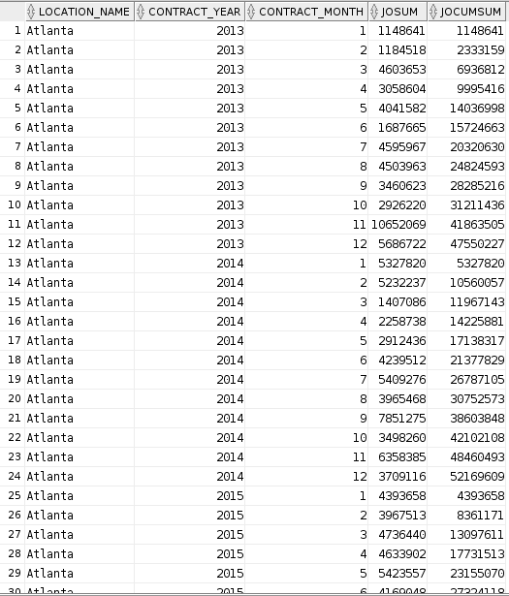

2. AQ2

SELECT l.location_name,   
       t.time_year                            AS contract_year,   
       t.time_month                           AS contract_month,   
       **Avg**(j.unit_price * j.quantity_ordered) AS JOSum,   
       **Avg**(**Avg**(j.unit_price * j.quantity_ordered))   
         over (   
           PARTITION BY l.location_name   
           ORDER BY t.time_year, t.time_month ROWS BETWEEN 11 preceding AND   
         CURRENT ROW   
         )                                    AS JOCumSum   
FROM   w_job_f j,   
       w_location_d l,   
       w_time_d t   
WHERE  j.location_id = l.location_id   
       AND j.contract_date = t.time_id   
GROUP  BY l.location_name,   
          t.time_year,   
          t.time_month

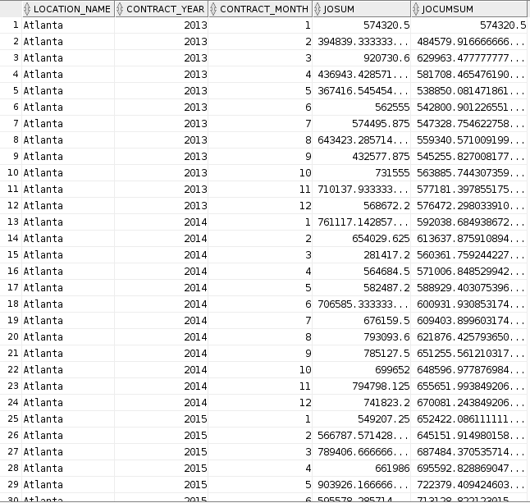

3. AQ3

SELECT l.location_name,   
       t.time_year                               AS contract_year,   
       t.time_month                              AS contract_month,   
       **SUM**(i.iasum - x.costs)                    AS Profit,   
       **Rank**()   
         over (   
           PARTITION BY t.time_year   
           ORDER BY **SUM**(i.iasum - x.costs) DESC) AS ProfitRank   
FROM   w_job_f j,   
       w_location_d l,   
       w_time_d t,   
       invoice_summary i,   
       (SELECT **SUM**(sj.cost_labor + sj.cost_material   
                   + sj.cost_overhead + mc.machine_costs) AS costs,   
               sj.job_id   
        FROM   w_sub_job_f sj,   
               machine_costs mc   
        WHERE  sj.sub_job_id = mc.sub_job_id   
        GROUP  BY sj.job_id) x   
WHERE  j.location_id = l.location_id   
       AND j.contract_date = t.time_id   
       AND j.job_id = i.job_id   
       AND j.job_id = x.job_id   
GROUP  BY l.location_name,   
          t.time_year,   
          t.time_month

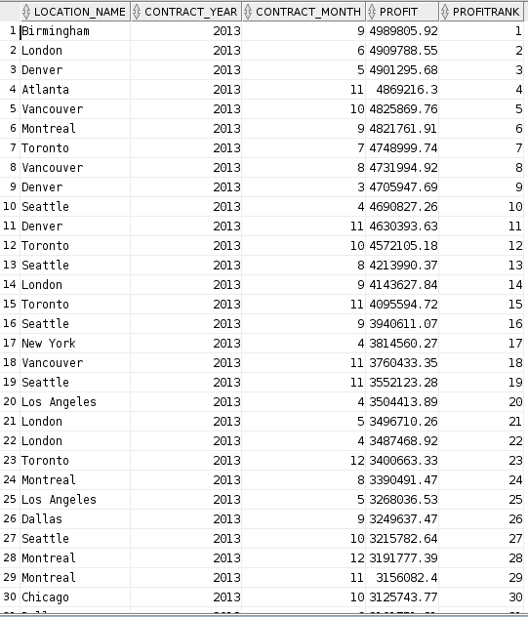

4. AQ4

SELECT l.location_name,   
       t.time_year                                       AS contract_year,   
       t.time_month                                      AS contract_month,   
       **SUM**(i.iasum - x.costs) / **SUM**(i.iasum)             AS Margin,   
       **Rank**()   
         OVER (   
           PARTITION BY t.time_year   
           ORDER BY **SUM**(i.iasum - x.costs) / **SUM**(i.iasum) DESC) AS MarginRank   
FROM   w_job_f j,   
       w_location_d l,   
       w_time_d t,   
       invoice_summary i,   
       (SELECT **SUM**(sj.cost_labor + sj.cost_material   
                   + sj.cost_overhead + mc.machine_costs) AS costs,   
               sj.job_id   
        FROM   w_sub_job_f sj,   
               machine_costs mc   
        WHERE  sj.sub_job_id = mc.sub_job_id   
        GROUP  BY sj.job_id) x   
WHERE  j.location_id = l.location_id   
       AND j.contract_date = t.time_id   
       AND j.job_id = i.job_id   
       AND j.job_id = x.job_id   
GROUP  BY l.location_name,   
          t.time_year,   
          t.time_month

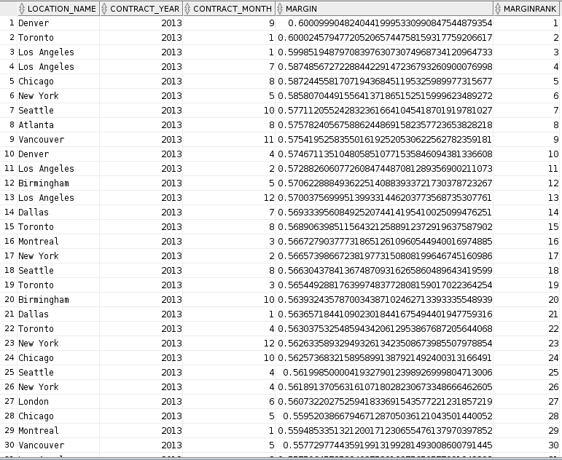

5. AQ5

SELECT j.job_id,   
       l.location_name,   
       t.time_year                                         AS contract_year,   
       t.time_month                                        AS contract_month,   
       **SUM**(i.iasum - x.costs) / **SUM**(i.iasum)               AS Margin,   
       **Percent_rank**()   
         over (   
           ORDER BY **SUM**(i.iasum - x.costs) / **SUM**(i.iasum)) AS MarginRank   
FROM   w_job_f j,   
       w_location_d l,   
       w_time_d t,   
       invoice_summary i,   
       (SELECT **SUM**(sj.cost_labor + sj.cost_material   
                   + sj.cost_overhead + mc.machine_costs) AS costs,   
               sj.job_id   
        FROM   w_sub_job_f sj,   
               machine_costs mc   
        WHERE  sj.sub_job_id = mc.sub_job_id   
        GROUP  BY sj.job_id) x   
WHERE  j.location_id = l.location_id   
       AND j.contract_date = t.time_id   
       AND j.job_id = i.job_id   
       AND j.job_id = x.job_id   
GROUP  BY j.job_id,   
          l.location_name,   
          t.time_year,   
          t.time_month  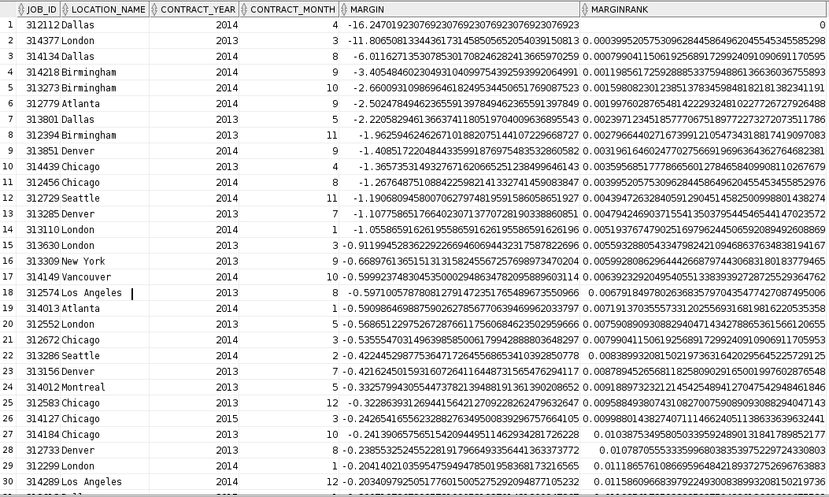

6. AQ6

SELECT job_id,   
       location_name,   
       contract_year,   
       contract_month,   
       margin,   
       marginrank   
FROM   (SELECT j.job_id,   
               l.location_name,   
               t.time_year                                 AS contract_year,   
               t.time_month                                AS contract_month,   
               **SUM**(i.iasum - x.costs) / **SUM**(i.iasum)       AS Margin,   
               **Percent_rank**()   
                 over (   
                   ORDER BY **SUM**(i.iasum - x.costs) / **SUM**(i.iasum)) AS MarginRank   
        FROM   w_job_f j,   
               w_location_d l,   
               w_time_d t,   
               invoice_summary i,   
               (SELECT **SUM**(sj.cost_labor + sj.cost_material   
                           + sj.cost_overhead + mc.machine_costs) AS costs,   
                       sj.job_id   
                FROM   w_sub_job_f sj,   
                       machine_costs mc   
                WHERE  sj.sub_job_id = mc.sub_job_id   
                GROUP  BY sj.job_id) x   
        WHERE  j.location_id = l.location_id   
               AND j.contract_date = t.time_id   
               AND j.job_id = i.job_id   
               AND j.job_id = x.job_id   
        GROUP  BY j.job_id,   
                  l.location_name,   
                  t.time_year,   
                  t.time_month)   
WHERE  marginrank >= .95

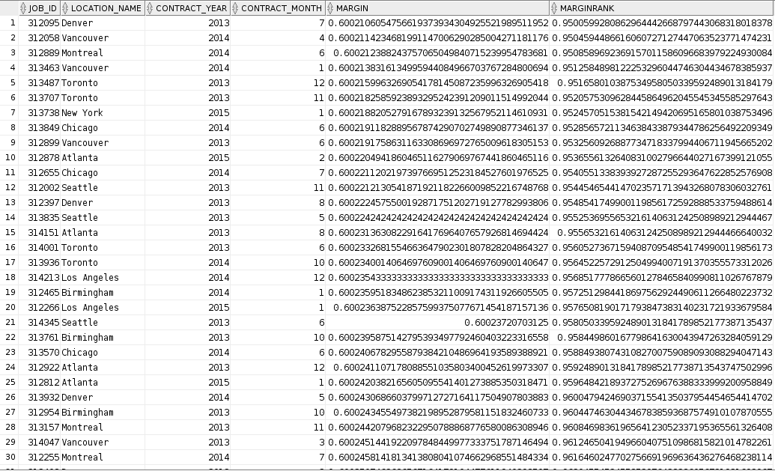

7. AQ7

SELECT sc.sales_class_desc,   
       t.time_year,   
       ( i.invoice_amount / i.invoice_quantity ) * (   
       i.quantity_shipped - i.invoice_quantity ) AS ReturnsSum,   
       **Rank**()   
         over (   
           PARTITION BY t.time_year   
           ORDER BY ( i.invoice_amount / i.invoice_quantity ) * (   
         i.quantity_shipped   
         - i.invoice_quantity ) DESC)            AS QuantityRank   
FROM   w_sales_class_d sc,   
       w_invoiceline_f i,   
       w_time_d t   
WHERE  sc.sales_class_id = i.location_id   
       AND i.invoice_sent_date = t.time_id

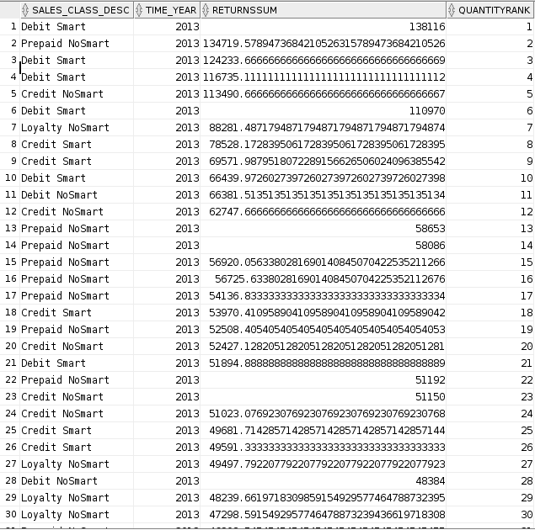

8.AQ8

SELECT sc.sales_class_desc,   
       t.time_year,   
       ( i.invoice_amount / i.invoice_quantity ) * (   
       i.quantity_shipped - i.invoice_quantity ) AS ReturnsSum,   
       **Ratio_to_report**(( i.invoice_amount / i.invoice_quantity ) * (   
                       i.quantity_shipped - i.invoice_quantity ))   
         over (   
           PARTITION BY t.time_year)             AS QuantityRank   
FROM   w_sales_class_d sc,   
       w_invoiceline_f i,   
       w_time_d t   
WHERE  sc.sales_class_id = i.location_id   
       AND i.invoice_sent_date = t.time_id

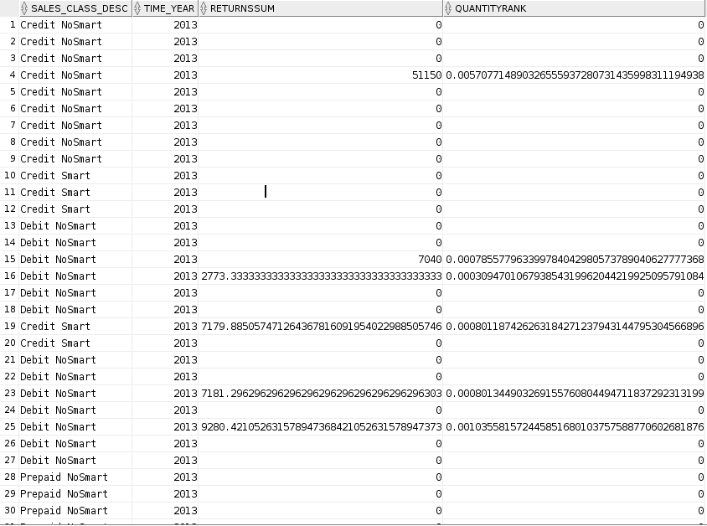

9. AQ9

SELECT l.location_name,   
       t.time_year   
       AS year_promised,   
       **Rank**()   
         over (   
           PARTITION BY t.time_year   
           ORDER BY **SUM**(**Getbusdaysdiff**(j.contract_date, x.firstshipdate)) DESC)   
       AS   
       BusDiffSumRank,   
       **Dense_rank**()   
         over (   
           PARTITION BY t.time_year   
           ORDER BY **SUM**(**Getbusdaysdiff**(j.contract_date, x.firstshipdate)) DESC)   
       AS   
       BusDiffSumDenseRank   
FROM   w_job_f j,   
       w_location_d l,   
       firstship x,   
       w_time_d t   
WHERE  j.location_id = l.location_id   
       AND j.job_id = x.job_id   
       AND j.date_promised = t.time_id   
GROUP  BY l.location_name,   
          t.time_year

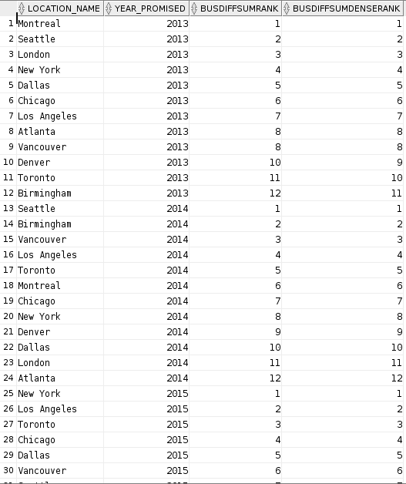

10. AQ10

SELECT l.location_name,   
       t.time_year   
       AS year_promised,   
       x.sumdelayshipqty,   
       **Rank**()   
         over (   
           PARTITION BY t.time_year   
           ORDER BY **Getbusdaysdiff**(x.last_shipment_date, j.date_promised) DESC)   
       AS   
       BusDiffRank   
FROM   w_job_f j,   
       w_location_d l,   
       shipment_delays x,   
       w_time_d t   
WHERE  j.location_id = l.location_id   
       AND j.job_id = x.job_id   
       AND j.date_promised = t.time_id

